My table name is my_iot_db

The partition key would be the time. It is the unique identifier for this table. This is the primary key also as it can uniquely identify each item.

The sort key is the device_id which indicates which device the data is being monitored with.

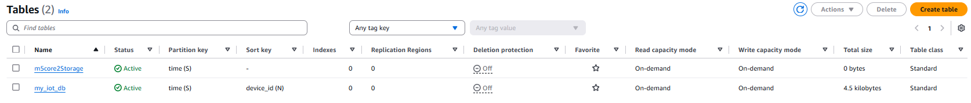



Below are the items that I have in my dynamo db. The attributes are time, device_id, aircon_temperature, co_levels, co2_levels, humidity and outside_temperature.

